CHAPTER 20: MULTITHREADING AND MULTITASKING **🖥️🧵**

In this chapter, we will break down how Windows handles **multitasking** and **multithreading**, with simple explanations, key concepts, and practical examples. We’ll also include insights from Charles Petzold's book to give context.

1. Multitasking **⏱️**

**Multitasking** is the ability of the operating system to run multiple programs at the same time.

* Windows does this by giving each program a **time slice**.
* Programs appear to run simultaneously, even if the CPU is only executing one instruction at a time.
* This improves **system responsiveness** and lets you switch between apps seamlessly.

**Evolution in Windows:**

* **16-bit Windows:** Used **cooperative multitasking**. Programs had to voluntarily give up CPU control. If one program “hung,” the whole system could freeze.
* **32-bit Windows:** Introduced **preemptive multitasking**. The OS actively manages CPU time, making sure no program monopolizes it.

2. Multithreading **🧵**

**Multithreading** is when a single program splits into multiple **threads**, which are lightweight units of execution within the program.

**Benefits of multithreading:**

* Run **background tasks** without freezing the interface.
* Keep **UI responsive** while other operations run.
* Execute **independent tasks in parallel**, improving performance on multiprocessor systems.

3. Key Terminology **📚**

* **Process:** A running program with its own memory and resources.
* **Thread:** A smaller execution unit inside a process. Threads share memory and resources with their parent process.
* **Context Switching:** Saving and restoring a thread’s state when switching to another thread.
* **Synchronization:** Methods to safely coordinate access to shared resources between threads, avoiding **race conditions** or data corruption.

4. Topics Covered in Chapter 20 **✅**

**Thread Creation and Management**

* Use CreateThread to start a new thread.
* Threads can have **priorities** set, and you can **suspend**, **resume**, or **terminate** them.

**Synchronization Techniques**

* Prevent conflicts when threads access shared data using:
  + **Critical Sections** – fast, process-local locks.
  + **Mutexes** – system-wide locks.
  + **Semaphores** – control access to a resource with limited availability.
  + **Events** – signal between threads.

**Thread-Specific Storage**

* Use TlsAlloc, TlsGetValue, and TlsSetValue to give each thread its own private data.
* Useful when multiple threads need independent copies of the same type of data.

**Win32 Timers**

* SetTimer and KillTimer schedule recurring or one-time events.
* Timers are handy for repeating tasks without blocking the main thread.

**Asynchronous Procedure Calls (APC)**

* Execute code asynchronously in a separate thread using:
  + BeginThreadEx – create a thread safely in Windows.
  + QueueUserAPC – queue code to run in a specific thread.

5. Best Practices in Multithreading

* Avoid **deadlocks** by careful locking order.
* Optimize **thread performance** by limiting unnecessary threads.
* Ensure **thread safety** when multiple threads access shared resources.

MULTITASKING IN THE DOS ERA

Before Windows made multitasking smooth, DOS had **ideas** but a lot of **practical limits**.

* Users **wanted multitasking** (running multiple programs at once).
* DOS **wasn’t built for it** — hardware and software got in the way.
* Early attempts were **creative but limited**.

Why DOS Struggled

I. Hardware Limits

* CPUs like the **Intel 8088** had **no memory management unit (MMU)**.
* Programs had to share **one flat memory space**, making juggling apps tricky.
* Moving memory blocks to free up space was slow and hard.

II. DOS Architecture

* DOS was **simple and lean** — designed for **single-tasking**.
* APIs were basic: mostly **file access** and **program loading**.
* No robust system services → developers couldn’t easily implement multitasking.

Think of DOS as a **tiny studio apartment**:

* Only one person (program) can comfortably live there at a time.
* You *could* squeeze in another, but furniture (memory) had to be constantly moved.
* Windows later gave everyone **their own rooms (protected memory & system services)** — suddenly multitasking made sense.

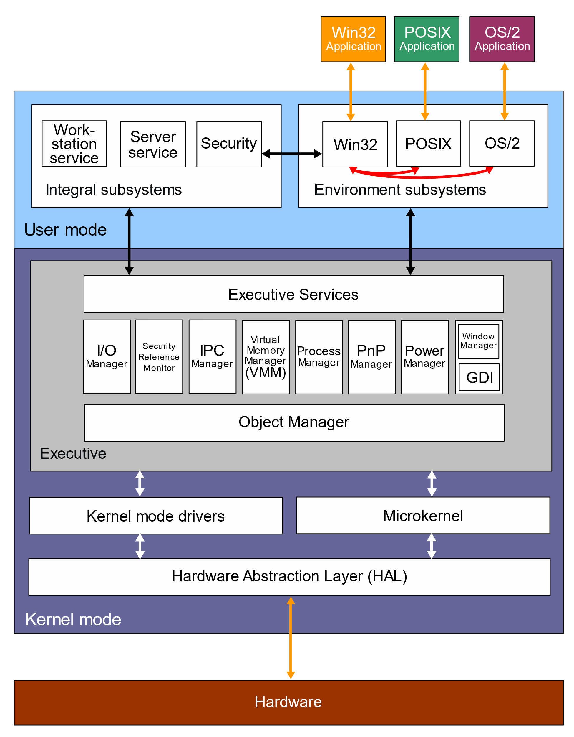

Creative Workarounds & Multitasking in DOS **🖥️✨**

Even though DOS wasn’t designed for multitasking, **clever programmers found ways to simulate it**.

1. TSR Programs (Terminate-and-Stay-Resident)

* TSRs stayed **in memory** after their main program closed, running in the background.
* Examples:
  + **Print spoolers:** used the hardware timer interrupt to print while you worked on another program.
  + **Borland SideKick:** temporarily paused your current app to show its interface, then returned control.
* TSRs were **early multitasking hacks**, letting small tools coexist with other programs.

2. Enhanced DOS Features

* Microsoft added **memory swapping to disk** and other tweaks.
* These **helped manage memory** better, indirectly supporting background activities.

3. Market Experiments

* **Task-switching shells** like **Quarterdeck DesqView** allowed running multiple DOS programs.
* Reality check: performance was slow, setup was tricky, adoption was limited.

4. Key Takeaways

* Multitasking was **desired by users**, even on single-user PCs.
* Programmers used **TSRs and simple task-switchers** to stretch DOS’s limits.
* These efforts **highlighted the need for OS-level multitasking**, eventually realized in Windows.

5. Exploration Ideas

* Study **popular TSRs**: what they did, how they worked.
* Dive into **DOS memory management** and **context switching** challenges.
* Compare DOS multitasking hacks vs. **Windows 3.x and later**, seeing how true multitasking became practical.

💡 Mental shortcut: DOS multitasking = **hacks in a single-room apartment**.

* TSRs = roommates who quietly exist in the background.
* Task-switchers = rotating chairs; clunky but functional.
* Windows = actual multiple rooms, each app gets space, fully coordinated.

Multitasking in Early Windows **⚡**

Early Windows (1.0, 1985) **brought multitasking out of DOS limitations**, giving multiple programs a graphical workspace and basic coordination.

1. Windows 1.0’s Multitasking Breakthrough

* **Graphical interface:** Multiple programs could run concurrently, unlike DOS command-line shells.
* **Cooperative multitasking (nonpreemptive):**
  + Programs only yield control voluntarily after processing messages.
  + Relies on well-behaved programs; a stuck program could freeze the system.
* **Message-based architecture:** Programs are idle until a message arrives.

**Workarounds & Limitations**

* **Preemption:** Used only for DOS programs or certain multimedia tasks (DLLs needing hardware timing).
* **Hourglass cursor:** Visual cue for busy programs.
* **Windows timer & PeekMessage:** Let programs periodically handle messages, preventing total freeze during long tasks.

2. Data Sharing Mechanisms

**a) Clipboard**

* **Basic & versatile:** For cut/copy/paste across applications.
* **Temporary storage:** Holds data for short-term transfer.
* **Manual operation:** User-controlled, not automatic.

**b) Dynamic Data Exchange (DDE)**

* **Live links:** Programs exchange data in real-time, even if idle.
* **Client-server model:** One app requests updates from another.
* **Examples:** Stock tickers, spreadsheets linked to databases.
* **Caveats:** Complex, fragile if connections fail.

**c) Object Linking and Embedding (OLE)**

* **Embedding objects:** One document can contain content from another program.
* **In-place editing:** Edit objects directly within the main document.
* **Example:** Edit a spreadsheet chart inside Word without launching Excel.
* **Use case:** Rich, interactive compound documents.

3. Key Points

* Clipboard → simple, manual data sharing.
* DDE → live updates between programs, more complex.
* OLE → seamless object integration for richer documents.
* 16-bit Windows used **cooperative multitasking**, with no enforced preemption.
* System responsiveness relied on programs yielding control voluntarily.

4. Further Exploration

* Investigate challenges of **preemptive multitasking** in 16-bit Windows.
* Study real examples of **application freezes or bottlenecks** under cooperative multitasking.
* Track the evolution toward **preemptive multitasking** in 32-bit Windows.
* Modern parallels: **Clipboard history, cloud sync**, **XML/JSON** for universal data exchange, and **OLE alternatives** like ActiveX or .NET components.

💡 Mental shortcut:

* DOS multitasking = roommates squeezing in one apartment.
* Windows 1.0 = a shared living room where everyone must **take turns politely**.
* Clipboard/DDE/OLE = ways to **pass notes between roommates without chaos**.

Multithreading & The Evolution of Input

1. The History Lesson: Why OS/2 Failed

Before Windows 95/NT, Microsoft and IBM built **OS/2 Presentation Manager (PM)**. It was a 32-bit operating system with a fatal flaw in how it handled user input.

**The Flaw: The Serialized Message Queue** In OS/2, the system had *one* single pipe for all keyboard and mouse clicks for every running program.

* **The Rule:** The system would not process Input B until the application finished processing Input A.
* **The Goal:** Predictability. If you type "ABC", the system guarantees "A" is processed before "B".
* **The Reality:** If one program crashed or hung while processing "A", the entire system froze. You couldn't click on another window because the mouse click was stuck in the queue behind "A".

**The Lesson:** A robust OS cannot let one bad app freeze the whole mouse.

2. The Windows Solution: Deserialized Input

Modern Windows (Win32 API) fixed this by giving every thread its own private message queue.

* **How it works:** When you click on Chrome, Windows looks at where the mouse is, determines which thread owns that window, and drops the message directly into *that specific thread's* queue.
* **The Benefit:** If Chrome hangs, Notepad keeps working. You can Alt-Tab away from a frozen program.

3. The Architecture of a Multithreaded App

In modern Windows programming, we divide labor to keep the application responsive.

**The "Governor & Staff" Model**

1. **The Primary Thread (The Governor):**
   * **Job:** Creates windows, runs the Message Loop, handles the UI (WM_PAINT, buttons).
   * **Rule:** Never do heavy lifting here. If you calculate Pi to the billionth digit here, the UI freezes, and the window says "(Not Responding)".
2. **The Secondary Threads (The Staff):**
   * **Job:** Long calculations, file I/O, networking.
   * **Rule:** They do *not* own windows. They crunch numbers in the background and tell the Governor when they are done.

4. What Threads Share vs. What They Keep

When you create a new thread, it is not a separate program. It lives inside the same "house" (Process).

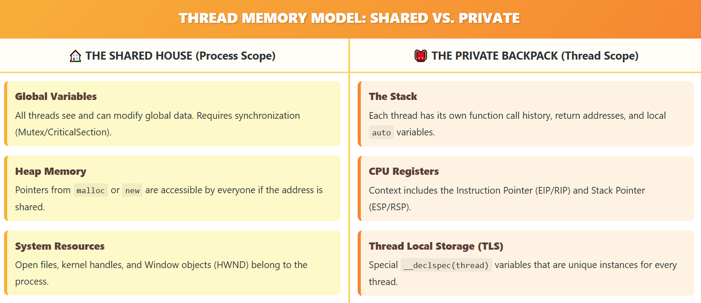

**The Danger:** Because they share global memory, two threads can try to write to the same variable at the exact same time, causing corruption (Race Conditions).

5. Summary Checklist

* **OS/2 PM** failed because one frozen app froze the whole system (Serialized Input).
* **Windows** succeeds because input is split per thread (Deserialized Input).
* **Primary Thread:** Handles UI/Messages.
* **Secondary Thread:** Handles heavy math/background work.
* **Threads share memory**, which makes them fast but dangerous (requires synchronization).

**Next Step:** Now that we know *why* we need threads, we need to look at **how to create them** using _beginthreadex vs CreateThread.

THREADING CHALLENGES & BEST PRACTICES

Multithreading is powerful, but it introduces a new class of bugs that are arguably the hardest to debug in all of computer science.

1. The Chaos: Race Conditions and Deadlocks

In a single-threaded program, you know exactly which line of code runs next. In a multithreaded program, the Operating System acts like a chaotic referee. It pauses Thread A and runs Thread B at random times—sometimes right in the middle of a calculation.

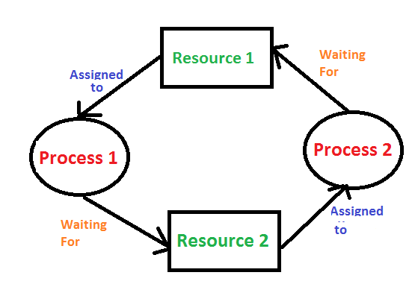

**The Race Condition** This happens when two threads try to change the same variable at the same time.

* *Thread A* reads Score = 10.
* *Thread B* reads Score = 10.
* *Thread A* adds 1 and writes 11.
* *Thread B* adds 1 and writes 11.
* *Result:* The score should be 12, but it is 11. Data is lost because they "raced" to write.

**The Deadlock** This happens when two threads stop and wait for each other.

* *Thread A* holds Key 1 and waits for Key 2.
* *Thread B* holds Key 2 and waits for Key 1.
* *Result:* They both wait forever. The program freezes.

2. The Fix: Synchronization

To stop the chaos, you need **Synchronization Primitives**. These are tools that force threads to wait their turn.

* **Critical Sections:** A block of code that only one thread can enter at a time. It is like a bathroom with a lock. If Thread A is inside, Thread B must wait outside until A leaves.
* **Semaphores:** Like a bouncer at a club. It allows a specific number of threads in at once (e.g., allowing 5 connections to a database).

3. The Hardware Reality: 16-bit vs 64-bit

**The Old Days (16-bit)** Processors were simple. Even adding 1 to a large number required two CPU cycles. If the OS interrupted the thread between cycle 1 and 2, the number would be corrupted. You had to lock everything.

**The Modern Era (64-bit)**

* **Atomicity:** Modern CPUs can read and write huge numbers (64-bit) in a single cycle. You don't need locks just to read a variable.
* **The New Danger (Optimization):** Modern CPUs are smart. They reorder your instructions to run faster. They might run Line 10 before Line 5 if they think it is safe. In multithreading, this can break your logic.
* **Takeaway:** Do not rely on hardware tricks. Always use proper Synchronization (locks) to be safe.

4. Windows Advancements

Windows evolved to make threading easier and safer.

**A. Deserialized Input (The Fix for Freezing)** - We covered this in the last section. Windows gives every thread its own input queue so a frozen background thread doesn't freeze the mouse cursor.

**B. Thread Local Storage (TLS)** Global variables are dangerous because all threads share them (leading to Race Conditions). TLS allows you to create a "Global" variable that is unique to each thread.

* If Thread A writes "Red" to *Color*, it sees "Red".
* If Thread B writes "Blue" to *Color*, it sees "Blue". They use the same variable name but look at different memory addresses.

5. The "New & Improved" Fallacy

Just because you *can* use threads doesn't mean you *should*. Threads add overhead. The CPU wastes time switching context between them.

**The 1/10 Second Rule (100 Milliseconds)** Use this rule of thumb to decide if you need a thread:

* **Task takes < 100ms:** Do not use a thread. Just run it. The user won't notice the tiny pause.
* **Task takes > 100ms:** Use a secondary thread. If you don't, the UI will freeze, and the user will think the app crashed.

6. Summary Checklist

1. **Race Conditions** happen when threads share data without locks.
2. **Deadlocks** happen when threads wait for each other.
3. **Critical Sections** prevent these bugs by forcing single-file access.
4. **TLS** gives threads private data.
5. **Only thread** if the task is slow (over 1/10th of a second).

The Two Ways to Spawn a Thread

a) The Raw Windows API (CreateThread)

This is the native function provided by the OS.

* **Pros:** It gives you granular control (Security attributes, Stack size).
* **Cons:** It does **not** set up the C Runtime (CRT).
* **The Danger:** If you use C functions like malloc, printf, or strtok inside a thread created with CreateThread, the program might crash or leak memory because the CRT data structures weren't initialized for that thread.

b) The C Runtime Helper (_beginthreadex)

This is the wrapper function provided by Microsoft's C library.

* **Pros:** It initializes the C Runtime, then calls CreateThread internally.
* **Cons:** Slightly different syntax.
* **The Rule:** Always use _beginthread (or _beginthreadex) if your thread uses any C library functions.

**Comparison Table:**

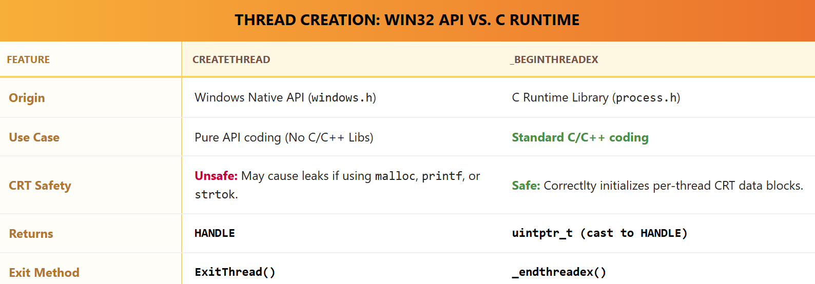

The Random Rectangles Program (RNDRCTMT.C)

This program demonstrates the simplest possible multithreaded app:

* **Thread 1 (Main):** Handles the Window (Resizing, Closing).
* **Thread 2 (Worker):** Draws random colored rectangles on the window background forever.

I. How it works:

1. **WinMain:** Registers the class and creates the window.
2. **WM_CREATE:** The main thread calls _beginthread(Thread, ...) to spawn the worker.
3. **The Worker Loop:**
   * It sits in a while(TRUE) loop.
   * It generates random x, y, color values.
   * It calls Rectangle to draw on the screen.
4. **WM_SIZE:** When you resize the window, the Main Thread updates the global variables cxClient and cyClient. The Worker Thread reads these new values instantly and starts drawing in the new area.

II. The Compiler Setting (Crucial!)

You cannot just compile this code normally. You must tell the compiler: *"I am using threads."*

* **The Switch:** /MT (Multithreaded Static) or /MD (Multithreaded DLL).
* **The Library:** It links against LIBCMT.LIB.
* **What it does:** It changes standard functions like strtok. In a single-threaded app, strtok uses a static variable to remember where it left off. In a multithreaded app, LIBCMT replaces that static variable with **Thread Local Storage (TLS)** so two threads using strtok at the same time don't corrupt each other's strings.

III. Critical Bug Warning (Synchronization)

The RNDRCTMT.C example is simple, but it has a **Hidden Race Condition**.

**The Shared Data:** cxClient and cyClient (Window Size).

**The Race:**

* Thread 1 (Main) is writing cxClient = 500.
* Thread 2 (Worker) is reading cxClient.

It is possible for Thread 2 to read the variable *while* Thread 1 is halfway through writing it (on 16-bit systems especially).

**The Fix:** Real programs need a **Critical Section** to lock the variable while reading/writing.

IV. Summary Checklist

1. Use _beginthread instead of CreateThread to keep malloc safe.
2. Enable the **Multithreaded (/MT)** setting in your compiler.
3. **Global Variables** are the easiest way for threads to talk, but they are dangerous without locks.
4. **Automatic Variables** (inside functions) are safe; every thread gets its own copy on its own stack.

The Multitasking Contest (MULTI1 vs MULTI2)

This section compares two ways to solve a classic 1986 programming problem: "How do you run 4 distinct tasks in 4 separate windows at the same time?"

The Tasks:

1. Window 1: Count up (1, 2, 3...).
2. Window 2: Find Prime Numbers.
3. Window 3: Calculate Fibonacci Sequence.
4. Window 4: Draw random circles.



1. The Old Way: MULTI1 (The Simulation)

**The Strategy: The Juggler** MULTI1 does not use threads. It uses a **Timer**. It relies on a single main loop. Every 10 milliseconds, the timer fires a WM_TIMER message. The program catches this message and quickly updates Window 1, then Window 2, etc.

**Why it works:** Computers are fast. If you switch between tasks quickly enough, it *looks* like they are happening at the same time.

**The Flaw:** This is "Cooperative Multitasking." If Window 2 gets stuck calculating a massive Prime Number, Windows 3 and 4 stop updating. The entire application freezes until the calculation is done.

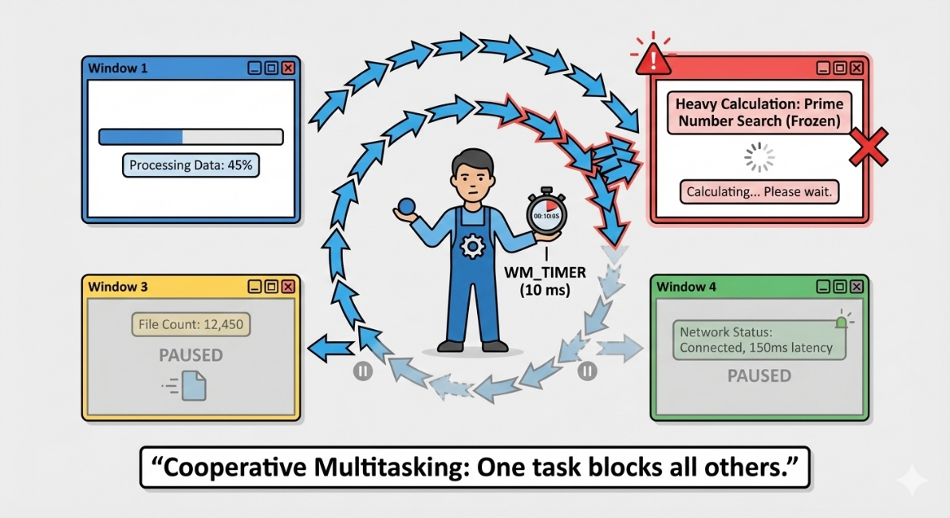

2. The New Way: MULTI2 (True Multithreading)

**The Strategy: The Team** MULTI2 creates 5 threads total.

1. **Main Thread:** Handles the UI (moving windows, clicking menus).
2. **4 Worker Threads:** Each window gets its own dedicated thread created with _beginthread.

**The Differences:**

* **No Timer:** The worker threads don't wait for a "tick." They run while loops as fast as the CPU allows.
* **Struct Passing:** Since _beginthread only accepts one argument, we pack the data (Window Handle, Window Size, Kill Flag) into a PARAMS structure and pass the pointer.
* **Responsiveness:** If the Prime Number thread gets stuck on a hard calculation, the Circle thread keeps drawing. The Main thread keeps responding to the mouse.

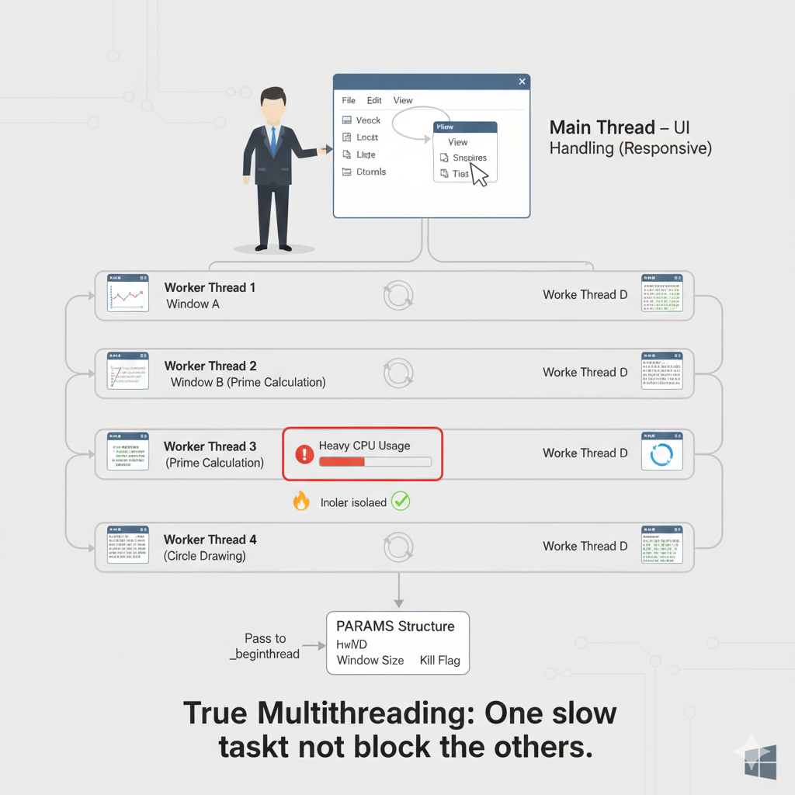

3. The Danger: The "bKill" Race Condition

MULTI2 introduces a serious bug that MULTI1 didn't have.

**The Scenario:** You have a boolean flag called bKill. When the user closes the window, the Main Thread sets bKill = TRUE. The Worker Thread checks this flag; if it is TRUE, it stops.

**The Crash (Race Condition):**

1. Worker Thread checks bKill. It is **FALSE**.
2. *Context Switch happens.* The OS pauses the Worker and runs the Main Thread.
3. User closes the window. Main Thread destroys the window handle and sets bKill = TRUE.
4. *Context Switch happens.* The OS resumes the Worker.
5. Worker Thread (thinking bKill is still false) tries to draw on the window.
6. **CRASH.** The window handle is invalid.

**The Lesson:** You cannot rely on simple boolean flags to stop threads safely. In a real application, you must use **Synchronization Objects** (like Event Objects or Critical Sections) to ensure the window isn't destroyed while a thread is painting on it.

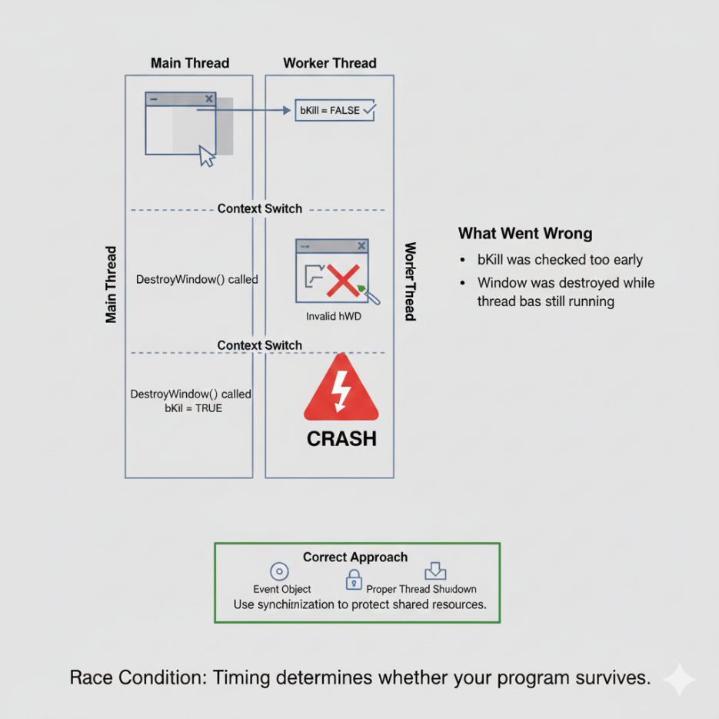

4. GDI and Threads

Windows GDI (Graphics Device Interface) has specific rules for threads:

* **Windows 98/Legacy:** Not thread-safe. If two threads try to draw at the exact same time, the system might crash.
* **Windows NT/Modern:** The OS "Serializes" GDI calls. It forces Thread B to wait if Thread A is drawing. This prevents crashes but slows performance.

**Best Practice:** Do not share GDI Objects (Pens, Brushes, Device Contexts) between threads. Give every thread its own tools.

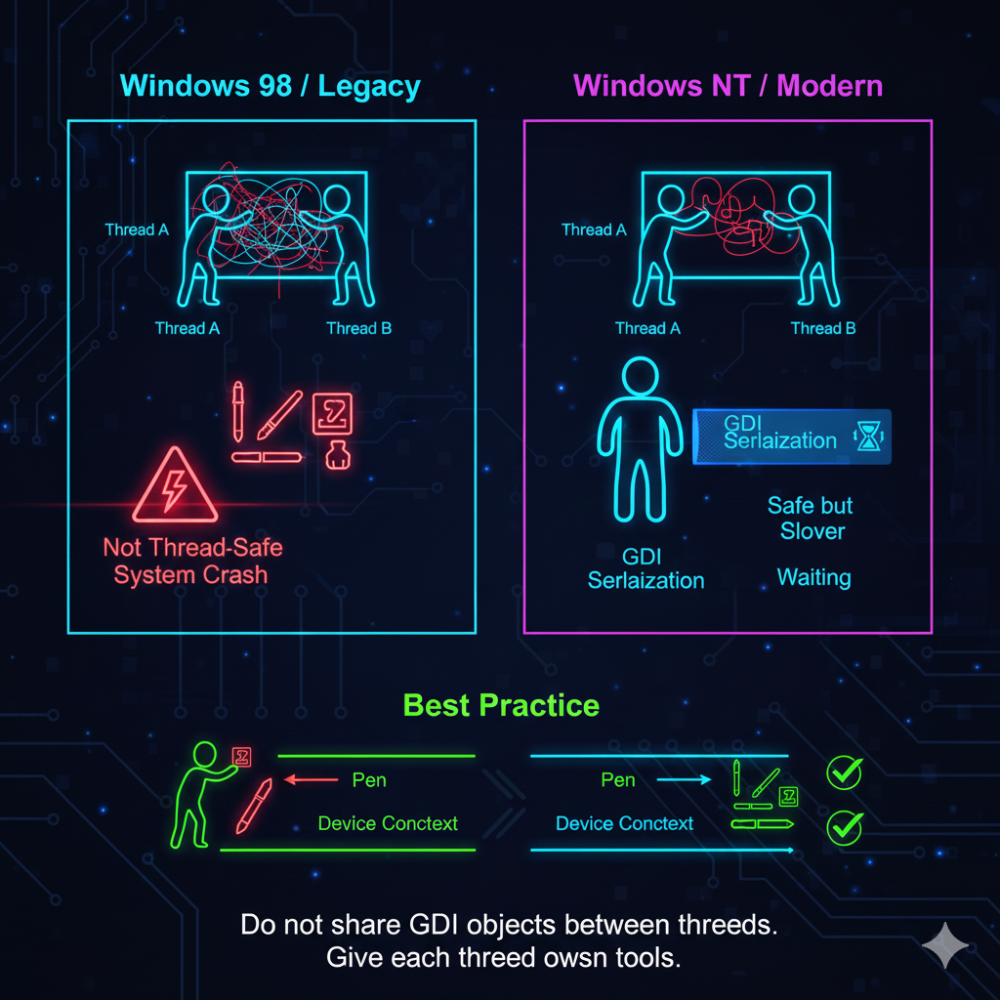

Summary Checklist

1. **MULTI1** fakes multitasking using WM_TIMER. It is safe but can freeze if one task is heavy.
2. **MULTI2** uses _beginthread for real multitasking. It is fast but dangerous.
3. **The Struct:** Use a structure to pass multiple arguments to a new thread.
4. **The Race:** Checking a variable (bKill) and acting on it is not an "Atomic" operation. The OS can interrupt you in the middle.
5. **The Fix:** Real multithreading requires **Synchronization** to prevent accessing dead memory.

SLEEP, SYNCHRONIZATION, AND CRITICAL SECTIONS

We established that multithreading causes chaos (Race Conditions). Now, let’s look at the tools we use to tame that chaos.

1. The Sleep Function: The "Pause" Button

Sleep(milliseconds) is the simplest way to control a thread.

* **What it does:** It tells the Operating System: *"Stop running me for X milliseconds. Let other threads use the CPU."*
* **The Sleep(0) Trick:** If you call Sleep(0), you tell the OS: *"I don't need to pause, but I am willing to give up the rest of my turn if anyone else is waiting."* It is a polite way to yield the processor.

**When to use it:**

* **Good:** In a background thread loop to prevent it from eating 100% CPU (e.g., check for new email every 5 seconds).
* **Bad:** In the Main Thread. Calling Sleep here freezes your window. The user cannot click anything until it wakes up.

2. The Traffic Jam: Why We Need Locks

Imagine a bank account with $100.

* **Thread A** tries to withdraw $10.
* **Thread B** tries to withdraw $10.

If they run at the exact same time:

1. Thread A reads balance ($100).
2. Thread B reads balance ($100).
3. Thread A writes new balance ($90).
4. Thread B writes new balance ($90).

* **Result:** You withdrew $20, but the balance only dropped by $10. The bank lost money.

We need a way to force Thread B to wait until Thread A is completely finished.

3. The Solution: Critical Sections

A Critical Section is a traffic light for code. It protects a specific block of memory.

**How it works (The 4 Steps):**

1. **Initialize:** Create the "Traffic Light" object (CRITICAL_SECTION).
2. **Enter:** Before you touch the shared data, call EnterCriticalSection.
   * *Effect:* If the light is Green, you pass. The light turns Red.
   * *Effect:* If the light is Red (someone else is inside), your thread **sleeps** immediately. You wait until it turns Green.
3. **Leave:** When you are done, call LeaveCriticalSection.
   * *Effect:* The light turns Green. If another thread was waiting, it wakes up and enters.
4. **Delete:** When the program ends, clean up the object.

The Code Example:

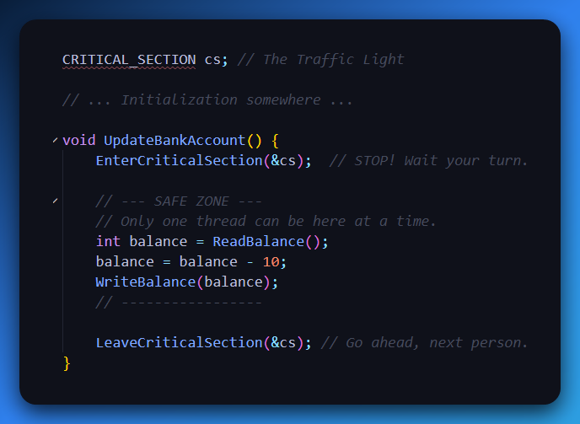

4. Alternative Tools

* **Mutex (Mutual Exclusion):** Similar to a Critical Section, but it works across *different programs* (e.g., syncing Word and Excel). Slower than Critical Sections.
* **Semaphores:** A counter. Instead of "Only 1 person," it allows "Up to 5 people." Good for limiting database connections.
* **Events:** A starting gun. Thread A sleeps until Thread B fires the "Event" signal.

5. Summary Checklist

1. **Sleep** pauses a thread to save CPU.
2. **Race Conditions** corrupt data when threads fight over memory.
3. **Critical Sections** lock a piece of code so only one thread runs it at a time.
4. **Enter/Leave:** You must always pair EnterCriticalSection with LeaveCriticalSection. If you forget to Leave, the program hangs forever (Deadlock).

UNDERSTANDING CRITICAL SECTIONS

Critical sections are synchronization mechanisms that enforce exclusive access to shared resources or code blocks by multiple threads within a process. This prevents race conditions and ensures data consistency.

1. Key Functions

Initializing a Critical Section:

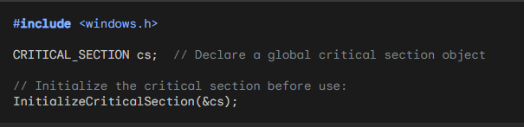

Entering a Critical Section:

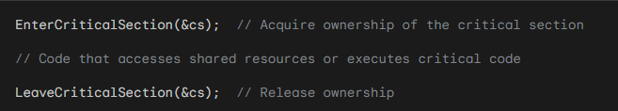

Deleting a Critical Section:

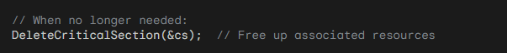



Events and Thread Signaling (BIGJOB1 & BIGJOB2)

We now understand how to *lock* threads (Critical Sections). Now, let’s learn how to *talk* to them.

1. The Core Concept: Signaling

In a multithreaded app, threads often need to wait for each other.

* **The Main Thread:** "I need the Worker Thread to start calculating now."
* **The Worker Thread:** "I am finished. Here is the result."

We could use a while loop to constantly check a variable (Polling), but that wastes 100% of the CPU. Instead, we use **Event Objects**. An Event Object is like a **Start Gun**.

* **Unsignaled State:** The gun is raised. Everyone waits.
* **Signaled State:** *BANG!* The gun fires. The waiting thread wakes up and runs immediately.



2. The BIGJOB1 Program (The "Create/Destroy" Method)

This program calculates a complex math benchmark ("Savage").

**The Strategy:**

1. **Start:** When you click "Start", the Main Thread calls _beginthread.
2. **Run:** The new thread runs the calculation loop.
3. **Finish:** When the calculation is done, the thread sends a message (WM_CALC_DONE) to the Main Window and then **destroys itself** (_endthread).

**The Communication Trick:** How does the Main Thread stop the calculation if the user clicks "Cancel"? It sets a boolean flag bContinue = FALSE. The Worker Thread checks this flag inside its for loop. If it sees FALSE, it aborts.

**The Flaw:** Creating and destroying a thread every time you click "Start" is slow (Thread Creation Overhead). It is better to keep the thread alive and just put it to sleep.

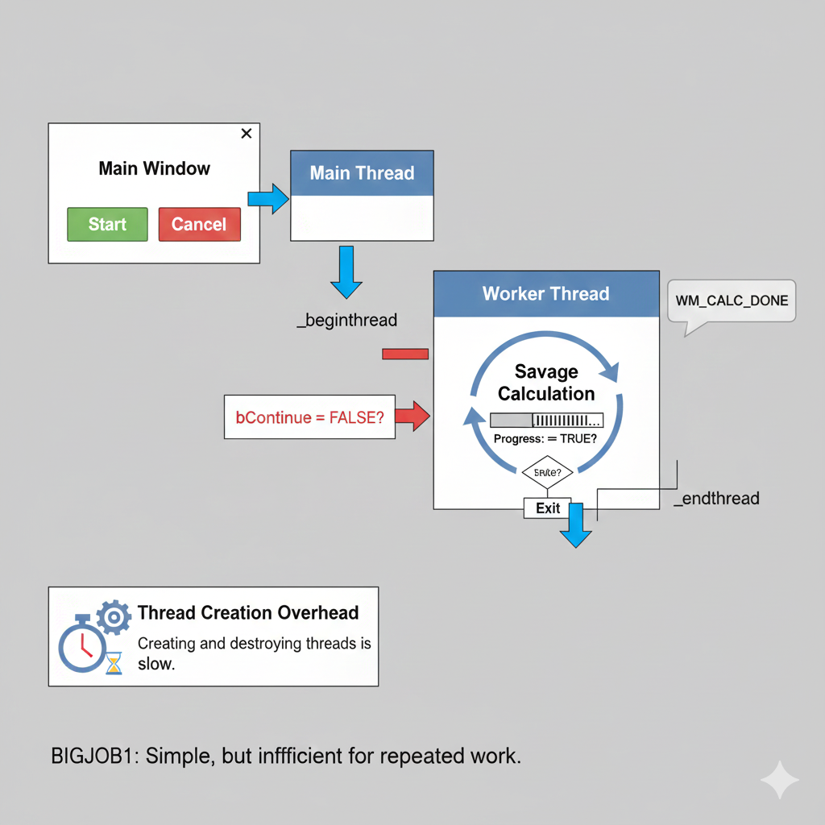

3. The BIGJOB2 Program (The "Event" Method)

This version is much smarter. It creates the Worker Thread *once* when the program starts.

**The Strategy:**

1. **Sleep:** The Worker Thread sits in an infinite loop, waiting at a WaitForSingleObject call. It consumes 0% CPU.
2. **Wake Up:** When you click "Start", the Main Thread calls SetEvent.
3. **Run:** The WaitForSingleObject sees the signal, wakes up, runs the calculation *once*, and then loops back to the top to wait again.

**The Key Functions:**

* **CreateEvent:** Makes the object.
  + *Auto-Reset:* Once one thread wakes up, the event automatically turns off (Unsignaled) so the thread doesn't run twice.
  + *Manual-Reset:* The event stays On until you manually turn it off.
* **SetEvent:** Fires the gun. Wakes up the waiting thread.
* **ResetEvent:** Reloads the gun (makes it Unsignaled).
* **WaitForSingleObject:** The thread pauses here until the Event is Signaled.

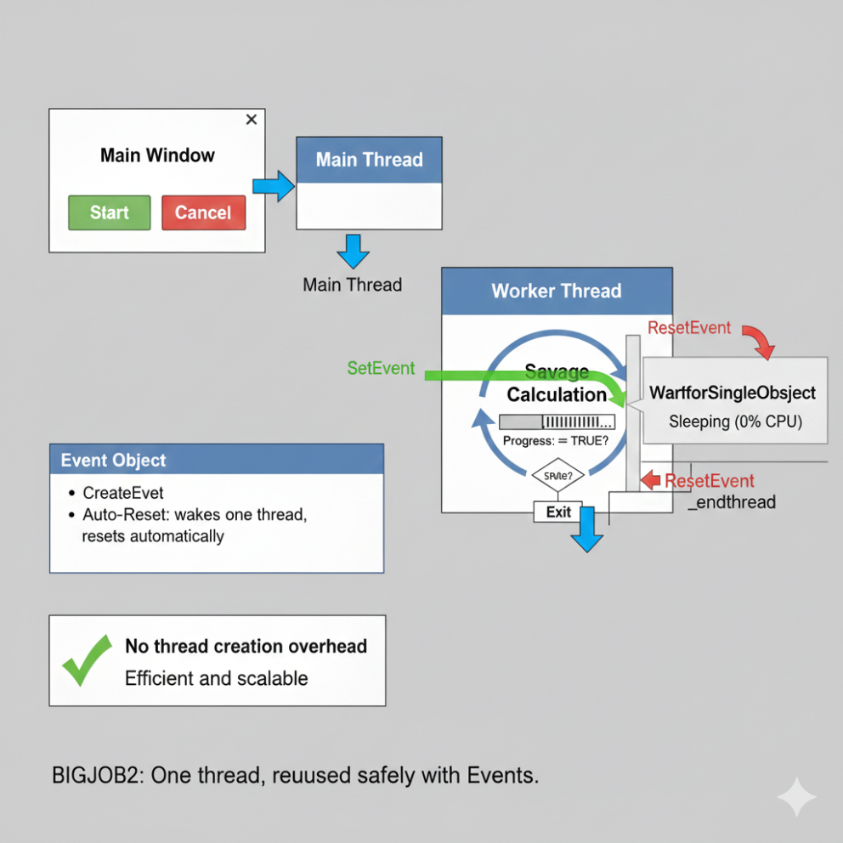

4. Comparison: Polling vs. Events

Bad (Polling):

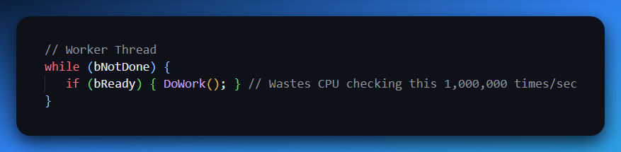

Good (Events):

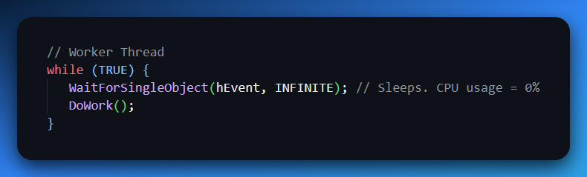

5. Summary Checklist

1. **Events** are the best way to coordinate threads without wasting CPU.
2. **SetEvent** wakes up a waiting thread.
3. **WaitForSingleObject** puts a thread to sleep until the signal comes.
4. **Auto-Reset Events** are safer for "Start Work" signals because they turn themselves off automatically.
5. **BIGJOB2** is better than BIGJOB1 because it reuses the thread instead of recreating it.

PERSISTENT THREAD MODEL:

Highlighting Advantages: Emphasizes how a single, persistent thread throughout program execution can lead to:

* Reduced overhead compared to repeated thread creation and destruction.
* Enhanced responsiveness due to the thread's immediate availability.
* Potential for improved performance through better resource utilization.

Exploring Synchronization Implications: Discusses the importance of synchronization mechanisms (e.g., critical sections, mutexes) in more complex scenarios where multiple threads might access shared data, ensuring thread safety and preventing race conditions.

Event-Driven Architecture:

Diving Deeper into Event Handling: Elaborates on the role of event objects in coordinating thread actions:

* Details how the window procedure signals the event object to trigger calculations.
* Explains how the worker thread waits for events to become signaled, entering a suspended state when idle and resuming upon notification.

Considering Alternative Event Types: Introduces the concept of manual-reset events, which remain signaled until explicitly reset, and their potential use cases in different synchronization patterns.

User Interaction and Status Display:

User Experience Focus: Emphasizes the importance of user-friendly interaction and clear feedback:

* Outlines how left mouse clicks initiate calculations and right mouse clicks abort them.
* Describes the informative status messages displayed in the window, indicating program state and calculation time.

Design Considerations: Proposes potential UI enhancements, such as progress bars or visual indicators, to further improve user experience and provide real-time feedback during calculations.

Code Structure and Components:

Window Procedure Deep Dive: Provides a more granular breakdown of the WndProc function's responsibilities:

* Explains how it handles various window messages, including creation, mouse events, custom messages from the worker thread, and window painting.
* Describes the management of the event object, PARAMS structure, and thread communication.

Worker Thread Breakdown: Delves into the Thread function's logic:

* Details its infinite loop structure, waiting for events and performing calculations.
* Explains the use of the bContinue flag to control abortion.
* Clarifies the communication of completion or abortion messages back to the window procedure.

Key Takeaways and Further Exploration:

Reinforcing Efficient Thread Handling: Reiterates the benefits of BIGJOB2's persistent thread approach for resource efficiency and responsiveness.

Stressing Event-Driven Benefits: Emphasizes the versatility of event objects for coordinating thread actions and enabling responsiveness in event-driven applications.

Expanding Horizons: Encourages further exploration of:

* Advanced synchronization techniques for complex multithreaded scenarios.
* Robust error handling strategies to gracefully manage potential thread failures or signaling issues.
* Performance optimization techniques, including alternative synchronization mechanisms and thread scheduling adjustments.

THREAD LOCAL STORAGE

Allows for persistent storage that is unique to each thread within a multithreaded program.

Necessary when multiple threads need to access and modify data independently without affecting other threads. The key functions are:

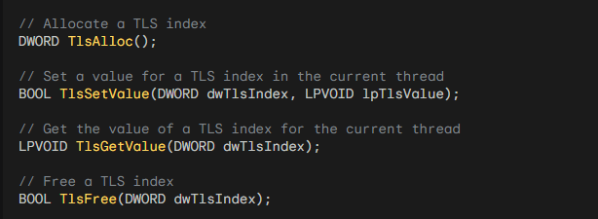

Steps for Using TLS:

Define a Data Structure: Define a data structure that represents the data you want to store in TLS. For example:

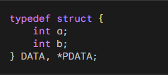

Allocate a TLS Index: Use the TlsAlloc function to allocate a TLS index. This index will be used to access the TLS data for each thread. Store the returned index in a DWORD variable. For example:



Set TLS Value in Each Thread: Before starting a thread, allocate memory for the TLS data using GlobalAlloc or any other memory allocation function. Cast the allocated memory to the data structure type and set it as the TLS value using the TlsSetValue function. For example:

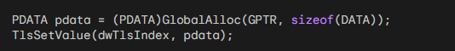

Get TLS Value in Any Function: In any function where you need to access the TLS data, retrieve the TLS value using the TlsGetValue function and cast it to the data structure type. You can then access and use the data as needed. For example:

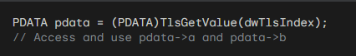

Free TLS Memory: When a thread finishes its execution, you should free the memory allocated for the TLS data using the appropriate memory deallocation function. You can retrieve the TLS value using TlsGetValue and then free the memory. For example:

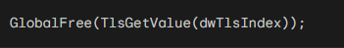

Free TLS Index: When you no longer need the TLS index, use the TlsFree function to free it. This should be done after all threads have finished using TLS. For example:



Remember:

* TLS provides a mechanism for thread-specific data, ensuring data integrity and isolation in multithreaded environments.
* Use it for variables that need to maintain unique values for each thread throughout their execution.
* Properly allocate, set, get, and free TLS resources to avoid memory leaks and errors.

THREAD LOCAL STORAGE (TLS): ENABLING THREAD-SPECIFIC DATA IN MULTITHREADED ENVIRONMENTS

Understanding the Need for TLS:

* In multithreaded programs, multiple threads often share access to global variables and heap memory.
* However, scenarios arise where threads need to maintain unique copies of certain variables, ensuring data integrity and preventing conflicts.
* TLS addresses this challenge by providing a mechanism to store data that is specific to each thread, ensuring isolation and preventing unintended modifications by other threads.

Windows API Functions for TLS Management:

* TlsAlloc: Grants an unused TLS index, serving as a unique identifier for a thread-local variable.
* TlsSetValue: Associates a value (typically a pointer to a memory block) with a given TLS index for the current thread.
* TlsGetValue: Retrieves the value associated with a TLS index for the current thread.
* TlsFree: Releases a previously allocated TLS index.

Example Code:

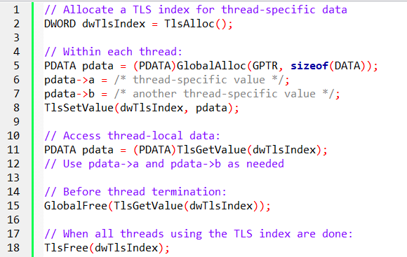

Microsoft C Extension: __declspec(thread)

Simplifies TLS usage by directly declaring thread-local variables:

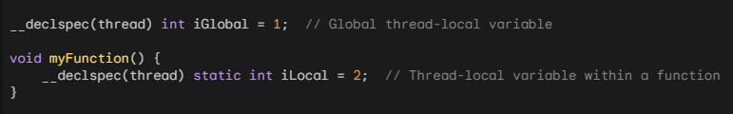

The __declspec(thread) extension in Microsoft C/C++ simplifies the usage of Thread Local Storage (TLS) by allowing you to directly declare thread-local variables. This extension is supported by the Microsoft C/C++ compiler and provides a convenient way to define thread-local variables without explicitly using the TLS API.

Here's how you can use the __declspec(thread) extension:

*Declare a Thread-Local Variable:*

To declare a thread-local variable, you can use the __declspec(thread) specifier before the variable declaration. For example:

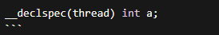

In the above example, the variable `a` is declared as a thread-local variable. Each thread will have its own separate copy of `a`, and changes made to `a` in one thread will not affect its value in other threads.

*Use the Thread-Local Variable:*

You can use the thread-local variable a in the same way as any other variable. For example:

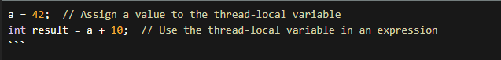

Each thread will have its own independent copy of `a`, and you can read from and write to `a` within each thread without worrying about thread synchronization or data interference.

It's worth noting that the `__declspec(thread)` extension can be used with various types of variables, including primitive types, structures, and pointers.

Benefits of __declspec(thread):

* Using the __declspec(thread) extension simplifies the usage of TLS by eliminating the need to explicitly allocate and manage TLS indices using the TLS API functions. It provides a more straightforward and concise syntax for declaring thread-local variables
* With __declspec(thread), the compiler takes care of allocating and managing the TLS storage for thread-local variables, making it easier to work with TLS in your code.

However, keep in mind that this extension is specific to the Microsoft C/C++ compiler and may not be portable across different compilers or platforms.

*Tell me more. How does the `__declspec(thread)` extension handle the initialization of thread-local variables? Are there any limitations or considerations when using the `__declspec(thread)` extension in Microsoft C/C++? Can you provide an example of how the `__declspec(thread)` extension can be used with structures or pointers?*

When it comes to the initialization of thread-local variables with the __declspec(thread) extension, each thread will have its own separate copy of the variable, and the initialization will occur automatically when a thread is created.

The initialization is performed once for each thread, ensuring that each thread starts with its own initialized copy of the variable. Here's an example to illustrate the initialization behavior of thread-local variables:

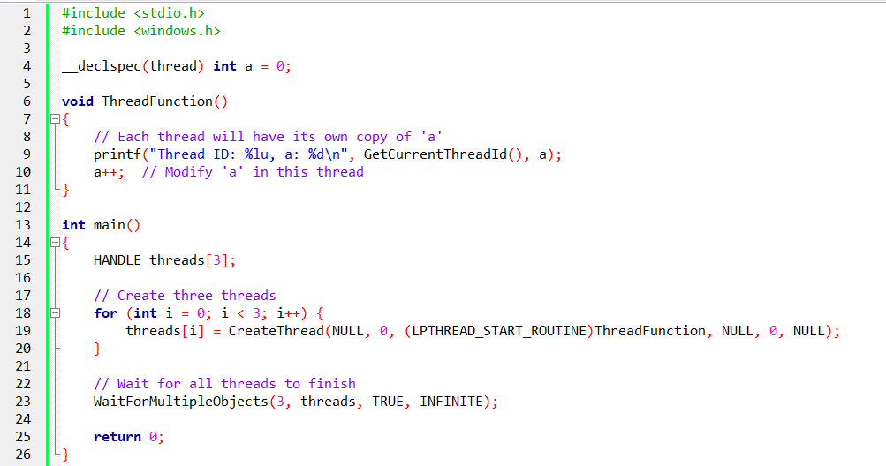

In this example, the a variable is declared as thread-local using __declspec(thread). Each thread will have its own copy of a, which is initialized to 0 automatically. The ThreadFunction is called from each thread, and they all access and modify their respective copies of a. The output will show that each thread has its own unique value of a.

Considerations and Limitations:

* The __declspec(thread) extension is specific to the Microsoft C/C++ compiler and may not be supported by other compilers or platforms. It is not part of the C/C++ language standard.
* Thread-local variables declared with __declspec(thread) are not suitable for inter-thread communication or synchronization. Each thread operates on its own independent copy of the variable, and changes made in one thread do not affect the copies in other threads.
* It's important to note that the initialization of thread-local variables with complex constructors or destructors is not supported with __declspec(thread). The initialization is limited to simple types or types with trivial constructors.

Example with Structures and Pointers:

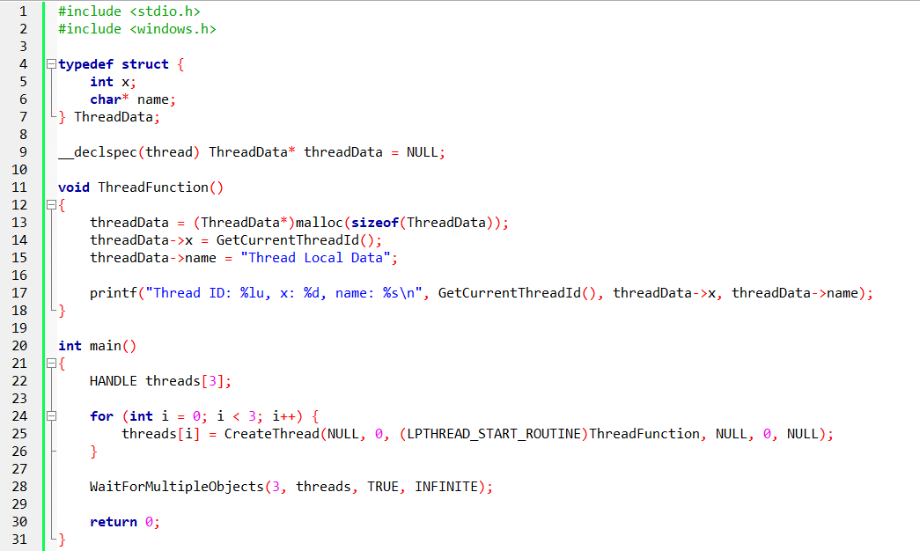

In this example, we declare a thread-local variable threadData of type ThreadData* (a pointer to a structure). Each thread will have its own separate copy of threadData. The ThreadFunction allocates memory for threadData and initializes its members. Each thread can access and modify its own copy of threadData.

*And that’s it for chapter 20 Multithreading…now to the final chapters.*